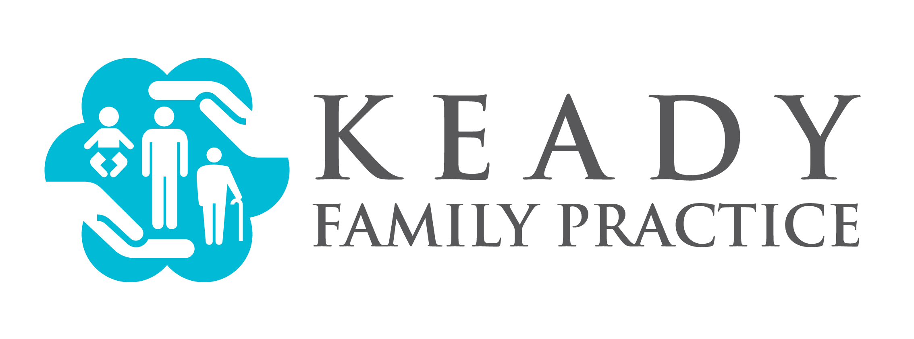

For Immediate Release:
KEADY FAMILY PRACTICE TO HAVE GRAND OPENING OF NEW CLAREMONT FACILITY 11/4/16 11:00am to 1:00pm; INCLUDES OPEN HOUSE AND REGISTRATION OF NEW PATIENTS
Claremont, NH; November 2, 2016
Media Contact:
Andrew Keady
akeady@kfpmed.com
PO Box 93 Charlestown NH, 03603
603-826-3434
Keady Family Practice will be conducting their grand opening for their new Claremont Primary Care office which is located on 132 Pleasant Street the building formerly occupied by Lane Eye Associates. The new facility will be the flagship facility to the primary care chain which includes offices in Charlestown (157 Main Street) and Newport (71 Belknap Ave). The grand opening of the new location will include an open house to the public and on-the-spot registration of new patients. Photo opportunities will be available with the providers at the facility.
Many in the community have requested the move into Claremont for quite some time. Dr. Keady, co-owner, is excited about the move into the community she states “I hope we can make a difference to the community’s health by offering affordable patient-centered care in the city of Claremont!” the opening of the Claremont facility. James Keady co-owner recently stated on the matter “The expansion into Claremont will help create a better continuum of health care for our patients by centralizing key services in our Claremont facility.” The practice also plans to work closely with Valley Regional Healthcare to help create a better continuity of healthcare and reduce incidents of unnecessary readmissions. Keady Family Practice will utilize their Claremont office to facilitate more urgent same-day appointments to reduce the rate of emergency room visits in the area.

